Airspeed Sensor and Segway into CAN

Contents

1 Links 2

2 CAN Protocol 2

2.1 Resources 2

2.2 Hardware 3

2.3 CAN Message Packet 3

2.4 Frames 4

3 Implementation 4

3.1 Libraries 4

3.2 Proof of Concept 5

3.3 Air Speed Sensor Integration Ideas 5

4 Pressure Transducer 6

5 Sensor SPI Interface 8

5.1 Payload description 9

6 TODOs 10

# Links

[Diagnosing CAN Bus Communication Problems](https://www.orionbms.com/general/diagnosing-canbus-communication-problems/)

# CAN Protocol

## Resources

Generic top level CAN explanations, good introductions.

[CAN Protocol Explained](https://www.youtube.com/watch?v=WikQ5n1QXQs)

[CAN Bus: A Beginner’s Guide](https://www.youtube.com/watch?v=YBrU_eZM110)

[The CAN Bus Protocol Tutorial](https://kvaser.com/can-protocol-tutorial/)

## Hardware

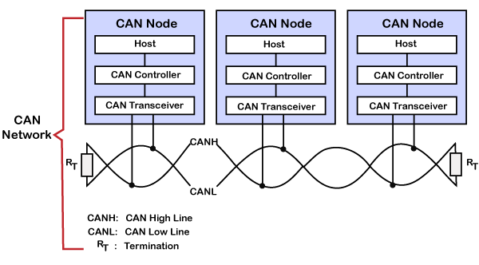

Rt: 120 Ohm termination resistors to match the impedance of a differential pair (bit transfer functionality and limits bit reflections on the line). 120 Ohm parallel equates to 60 Ohms series.

Bits: 1-recessive, 0-dominant. Bit recessive/dominant description is a consequence of the 120 Ohm termination resistors.

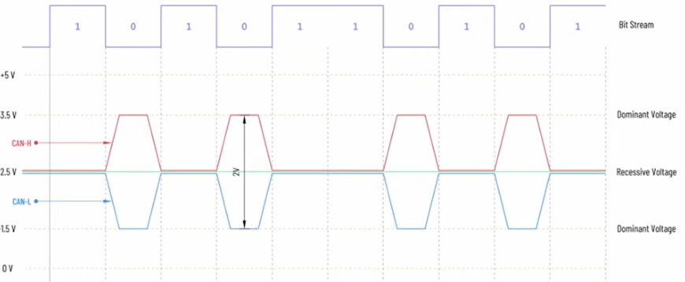

Noise: Differential pairing resolves common noise. There are recommended [cable/stub lengths](https://www.buenoptic.net/encyclopedia/item/537-maximum-cable-length-for-a-can-bus.html).

## CAN Message Packet

*CAN Packet*

SOF (start of frame): dominant zero

11-bit identifier: unique ID for each message. Message IDs with lower value are higher priority (relates to 0-dominant transmission functionality) in the bus arbitration assignment. “0” overpowers a “1” bit.

CAN network can be configured to work with two different message (or frame) formats: standard/base frame format (CAN 2.0 A and CAN 2.0 B) or the extended frame format (described only by a CAN 2.0 B).

* Base/Standard: supports a length of 11 bits for the identifier
* Extended: supports length 29 bits for the identifier. Extension to allow more message types to occupy a network.

## Frames

CAN has four frames:

1. Data: node data for transmission
2. Remote: Requesting the transmission of a specific identifier
3. Error: transmitted by any node detecting an error
4. Inject delay between data or remote frame

Data frame is the most commonly used.

# Implementation

## Libraries

For Arduino-STM32: <https://github.com/nopnop2002/Arduino-STM32-CAN>

## Proof of Concept

* Basic CAN communication between two uC established, integrated library

## Air Speed Sensor Integration Ideas

CAN bridge between airspeed sensor and main sensors/comms central uC.

Transmission:

Idea 1: CAN Bridge uC transmits airspeed sensor data (outputs data frame) periodically on an autonomous basis to the main sensors uC.

* Biased towards this idea first

Idea 2: Main Sensors uC periodically retrieves airspeed sensor data (request-response)

* Main Sensors uC sends a remote frame to CANBridge uC and CAN Bridge uC responds with most recent air speed sensor data
* This would be useful to save data logging space, don’t need to log airspeed when plane is not flying. Mechanical team interested in the maximum speed of the plane.

# Pressure Transducer

Exact part number: [4525DO-TP5AS005GPF](https://www.te.com/en/product-4525DO-TP5AS005GPF.html)

Sensor order breakdown:

* Package Type: Dual Sideport
* Supply Voltage: 3v3 Vdc
* Output Type: B 🡪 5% to 95%
* Interface Type: I2C (addr. 0x46H)
* Pressure Range (psi): 001
* Pressure Type: Differential A close-up of a text

  Description automatically generated

Transducer readings output gauge pressure. Variations in altitude and temperature will affect pressure.

# Sensor SPI Interface

[Interfacing to MEAS Digital Pressure Modules](https://www.amsys.de/downloads/notes/I2C-Interface-to-Digital-Pressure-Sensors-AMSYS-an802e.pdf)

[Application Note](https://www.te.com/commerce/DocumentDelivery/DDEController?Action=showdoc&DocId=Specification+Or+Standard%7FMS45xx_Application_Note%7FA1%7Fpdf%7FEnglish%7FENG_SS_MS45xx_Application_Note_A1.pdf%7FCAT-BLPS0041)

[Configuration, POR and Power Consumption](https://www.amsys-sensor.com/downloads/notes/Configuration-POR-and-Power-Consumption-AMSYS-an801e.pdf)

## Payload description

Data resolution: 14-bit pressure, 11-bit temperature

Status bits

* Implement flags, carry out with enums

# TODOs

* EMI test with motor and scope noise
* Integrated [Air Speed Sensor](https://rcdrone.top/products/pixhawk-px4-digital-airspeed-sensor-kit-differential-pitot-pitot-tube-air-speed-meter-for-pixhawk-autopilot-flight-controller?currency=USD&variant=44909919600864&utm_source=google&utm_medium=cpc&utm_campaign=Google%20Shopping&stkn=677f40c1dee9&gad_source=1&gclid=CjwKCAjwnK60BhA9EiwAmpHZw_iOQeMVey3sYSjgu3k655pOZhKnLSx8fwthNrIM7Hm9aGpOPE_JshoCwboQAvD_BwE)
  + [MS4525DO](https://www.te.com/commerce/DocumentDelivery/DDEController?Action=showdoc&DocId=Data+Sheet%7FMS4525DO%7FB10%7Fpdf%7FEnglish%7FENG_DS_MS4525DO_B10.pdf%7FCAT-BLPS0002)
  + [MS4515](https://www.te.com/commerce/DocumentDelivery/DDEController?Action=showdoc&DocId=Data+Sheet%7FMS4515%7FB8%7Fpdf%7FEnglish%7FENG_DS_MS4515_B8.pdf%7FCAT-BLPS0040)
* [Air velocity and flow measurement using a Pitot tube](https://www.sciencedirect.com/science/article/pii/S0019057898000366)
* [Flight Mechanics for Pilots](https://agodemar.github.io/FlightMechanics4Pilots/mypages/airspeeds/)
* Clarify the maximum expected airspeed of plane. Needed to determine calibration formula.
* Formalized wind tunnel with mount on aug31st?
* Start pcb?
* Start defining payload CAN

July 27, 2024

* Clarified pressure transducer functionality
* Research airspeed calculation. Can we incorporate temperature into the calculation to improve accuracy?
* Research wind tunnel.
* Plan wind tunnel schedule.